CHRISTEL HOUSE LEARNING CENTER
SUMMATIVE EXAMINATION 2025-26
GRADE 7
SUBJECT: Computer Science
DATE: MAX. MARKS: 15
I | Answer the following | 15 X 1 =15
Perform the activities related to Sorting Data, Number Formatting, and Chart Creation as shown in the given table:
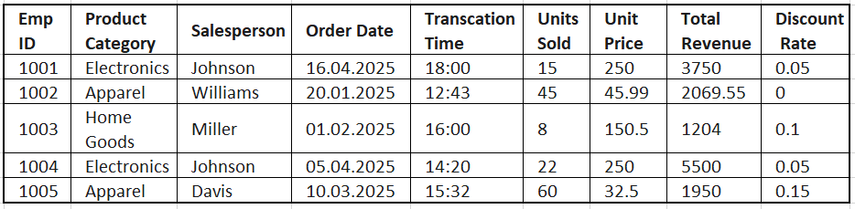
Using the given table, complete the following steps:
a) Sort the data by the Salesperson column in ascending (A–Z) order using the Custom Sort feature and Select the entire data table and apply All Borders, then apply a Thick Outside Border to outline the table clearly.
b) Apply the following Number Formatting to the specified columns:
- Total Revenue: Currency
- Units Sold: Number
- Order Date: Short Date
- Transaction Time: Time
- Discount Rate: Percentage (with 1 decimal place)
c) Create a chart to compare the Total Revenue for each Product Category, and complete the following within the chart:
- Identify and indicate the Product Category with the highest Total Revenue.
- Add a clear title to the chart.
- Label the X-axis and Y-axis appropriately.
- Apply a pre-set Chart Style of your choice for better visual presentation.

